Oracle Time and Labor
Configuration of Different Types of OTL Layouts
Creation Date: Jan 25, 2022

AUSTIN ARK
Plaza 7000 North Mopac Expressway
Suite 200
Austin, Texas – 78731
Email: contact@austinark.com

Creation Date: Jan 25, 2022

Table of Contents
Overview………………………………………………………………………………………………………………………………………3
Purpose…………………………………………………………………………………………………………………………………….....3
Background…………………………………………………………………………………………………………………………………..3
Solution………………………………………………………………………………………………………………………………………..3
OTL Configuration………………………………………………………………………………………………………………………….4

OVERVIEW
This guide demonstrates the necessary steps to configure different types of OTL layouts based on the client’s requirements.

PURPOSE
This document details the steps on how to configure different layouts based on the employees start and stop time and client requirements. This document also provides all the required pre-requisites. Tips on how to configure different OTL layouts based on the client’s requirement.

BUSINESS CASE
Our Client has different types of employees and different types of calculations are needed as employees will have data based on start and stop times, some of them have data based on several hours. Hence, based on employee category, we had to configure different types of OTL layouts.

SOLUTION
We created multiple OTL layouts, where the layouts are based on different HCM groups created and the HCM group has a criterion of different assignment categories.
As with all workarounds, apply first in Test and then apply in Production. By applying these steps for the employee, the client will be able to have different calculations based on different layouts.

Oracle Time and Labor Configuration

Element Configuration:
Please Login into the instance.
Navigation: - Navigator -> Payroll -> Payroll Calculation -> Click on action tab -> Manage Element.
There are 4 elements to be configured and corresponding element eligibility is to be created.
Click on the ‘+’ icon and create an element like the below screenshot.

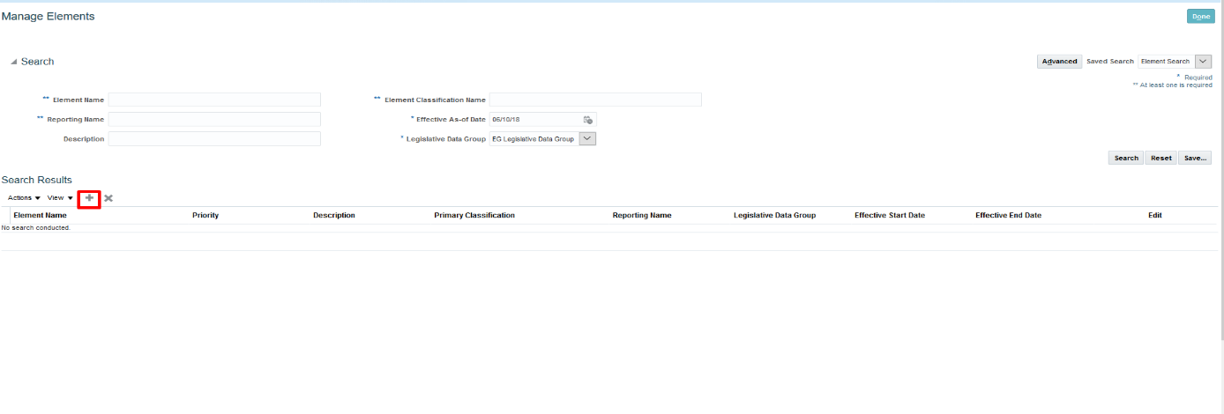

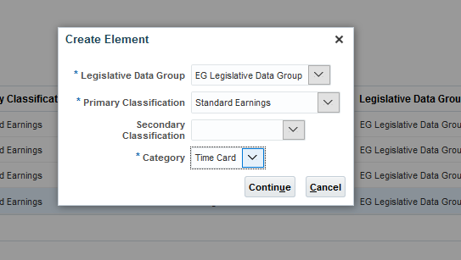

Regular Hours:

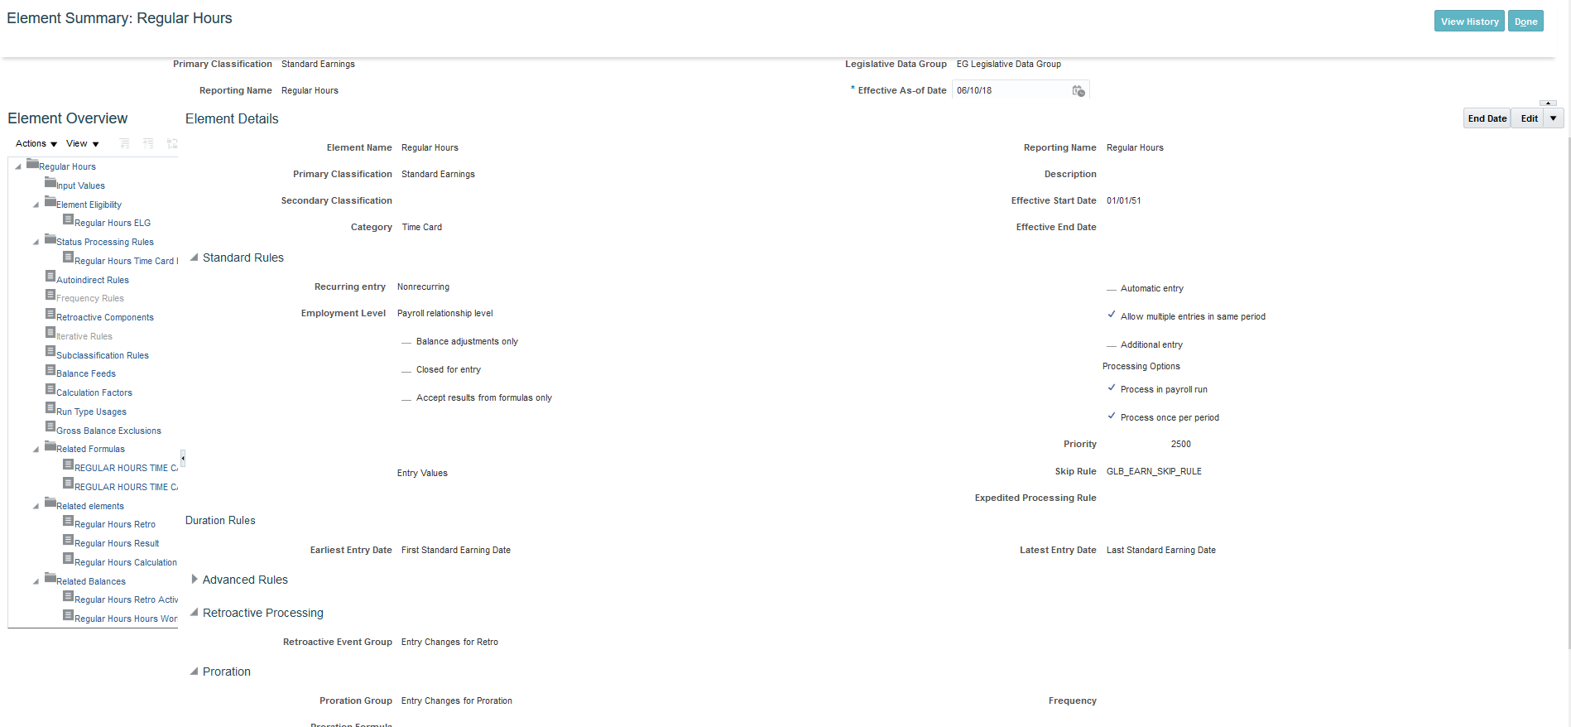

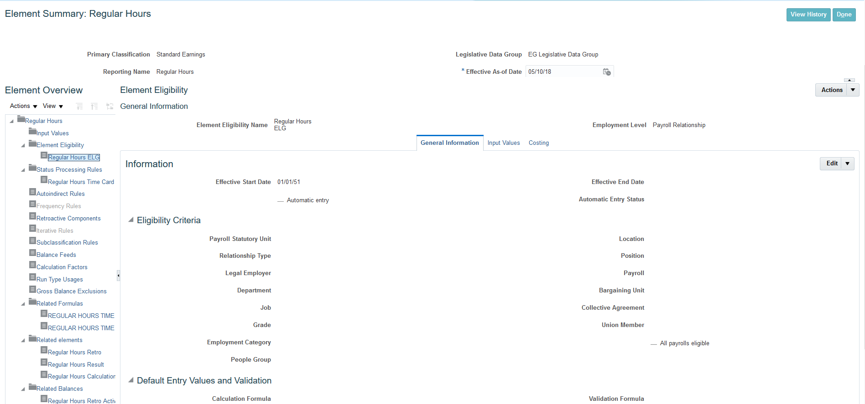

Overtime Hours

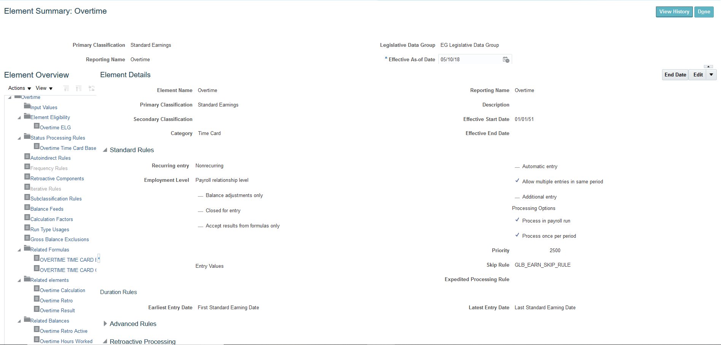

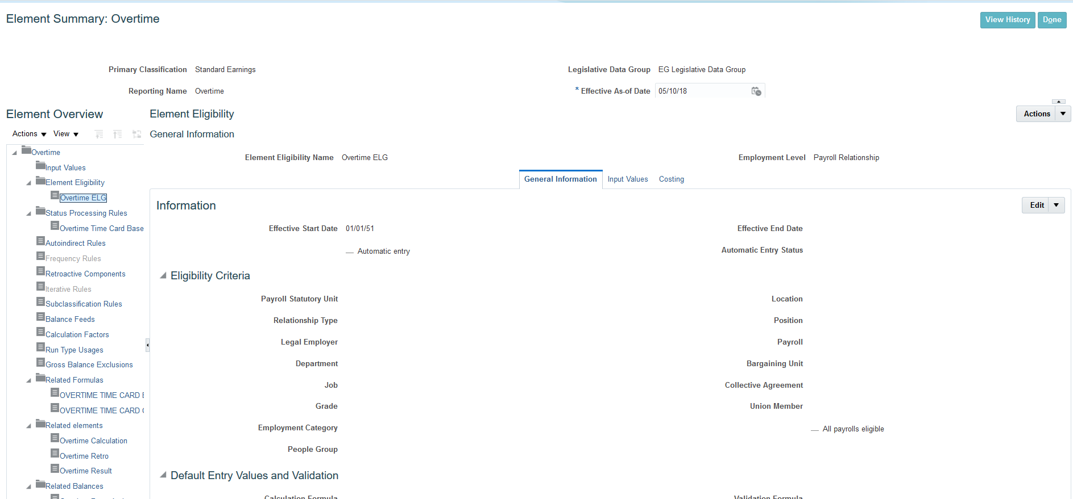

Lateness
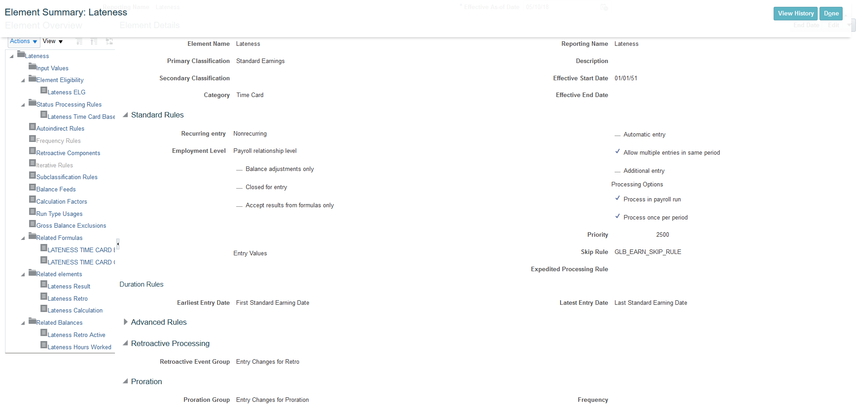

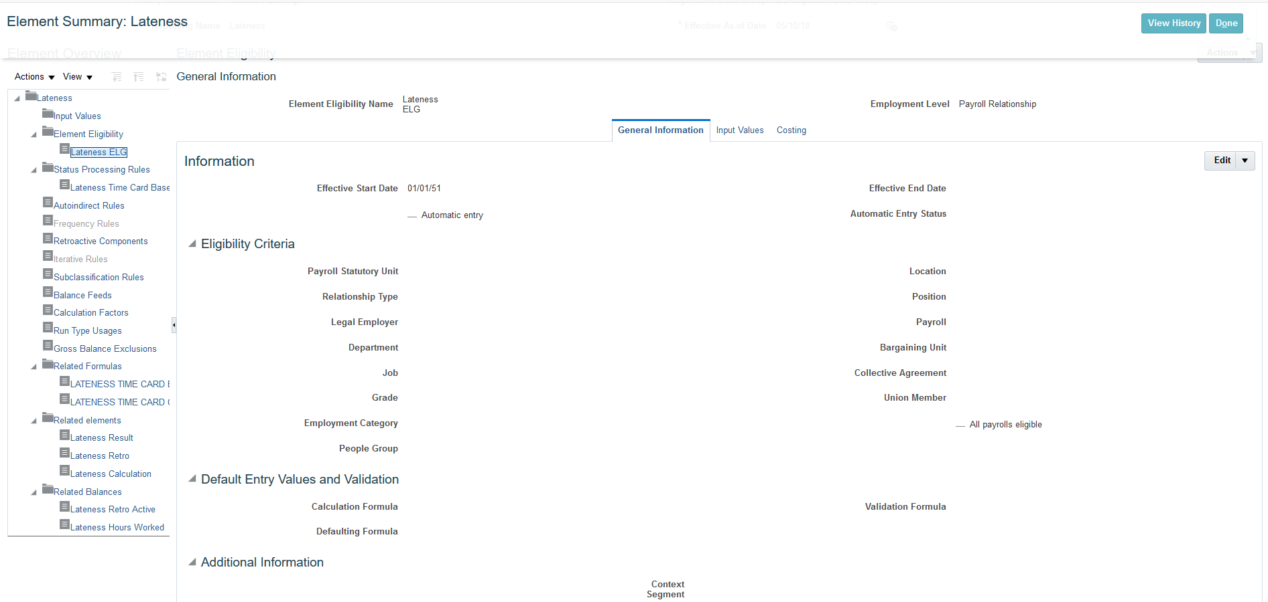

Early out
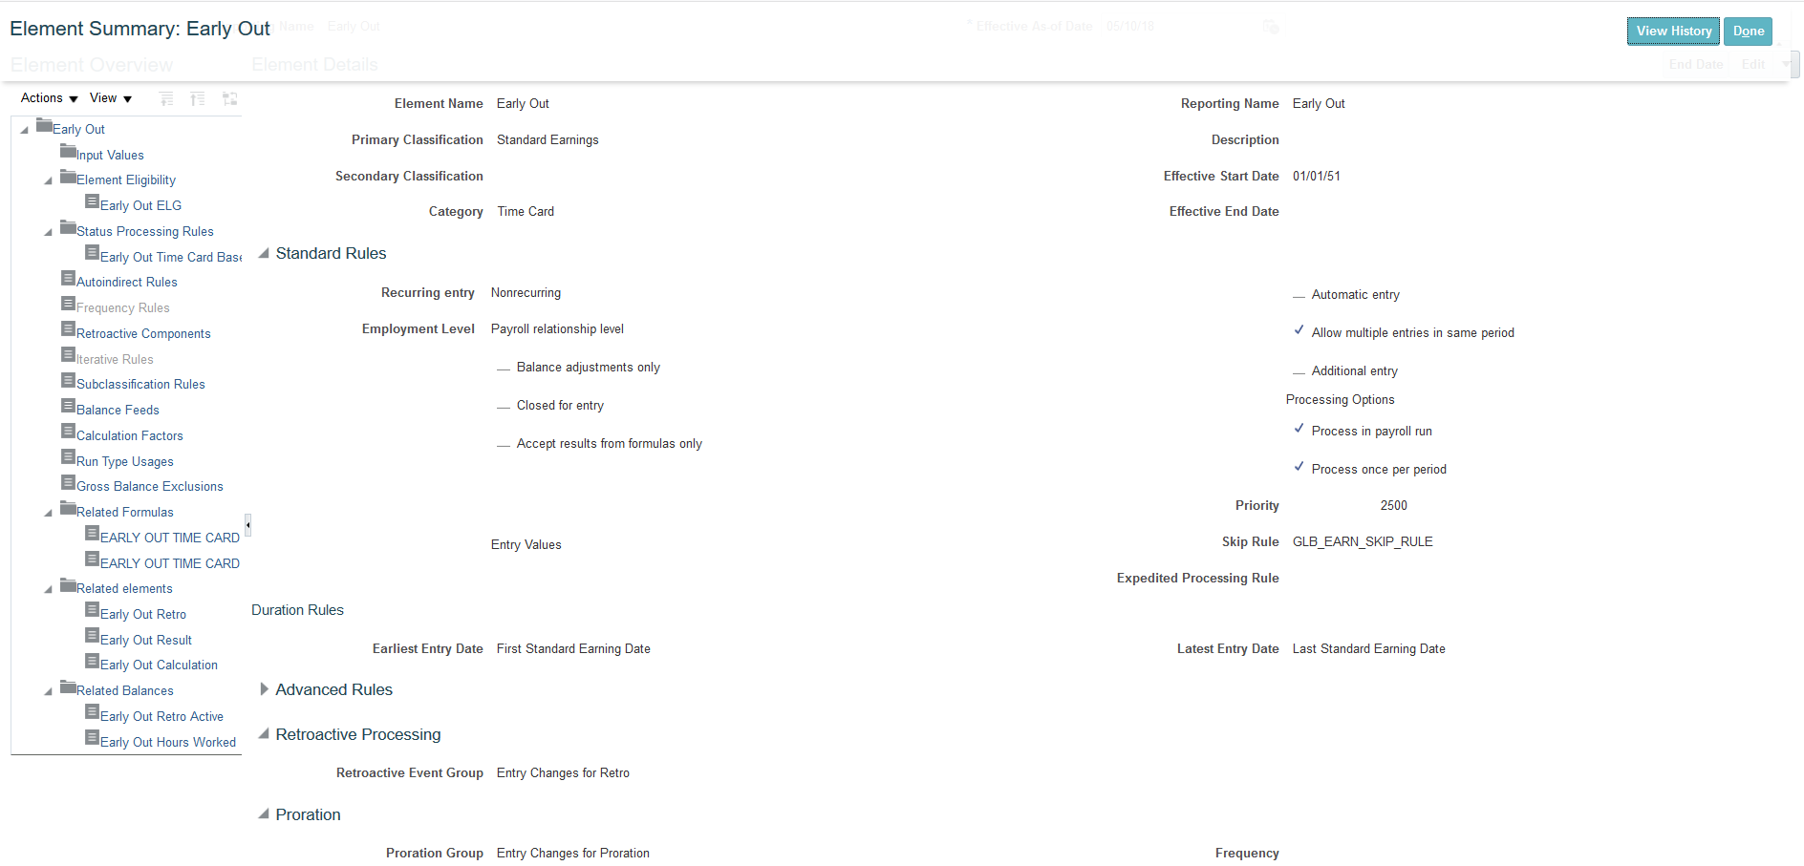

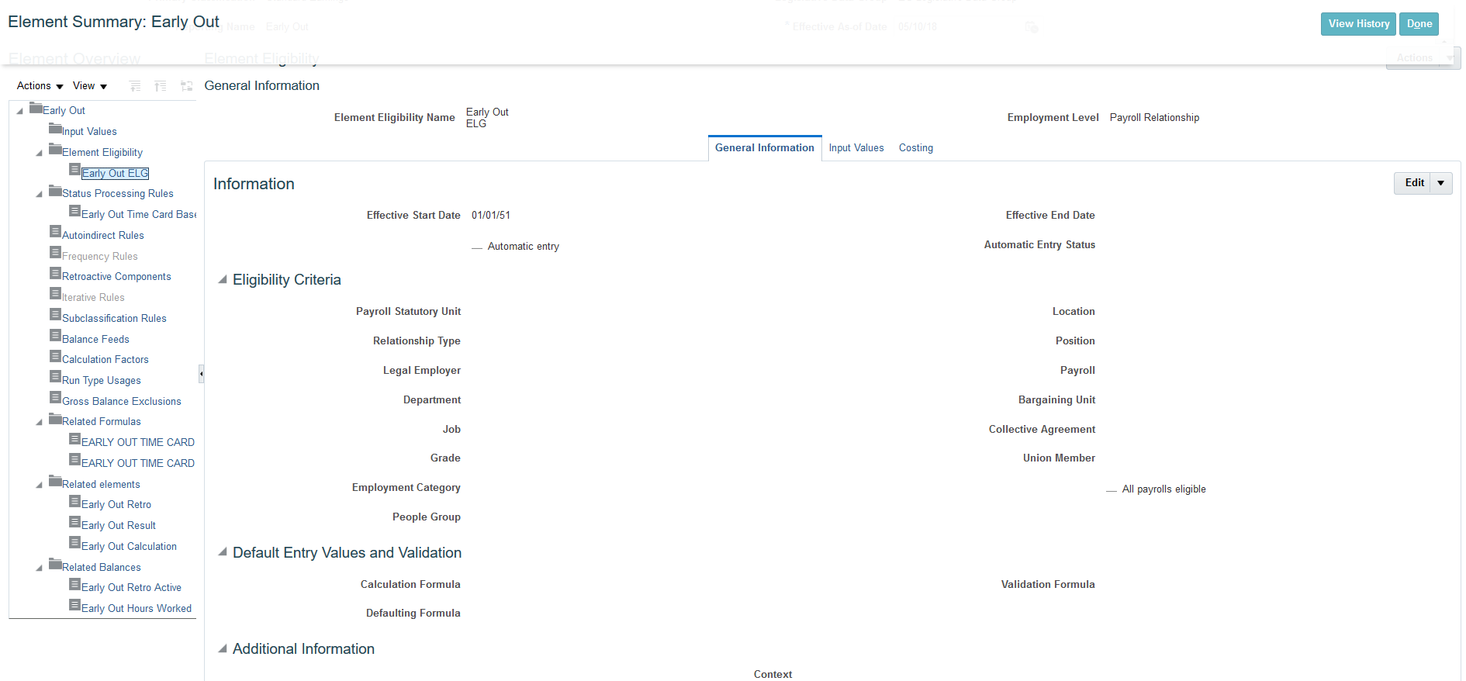

Manage time entry layout components
Navigation: - Navigator -> Setup and Maintenance -> Click on Action List -> Search for Manage Time Entry Layout Components.
Please Follow the Screenshot below for further configuration
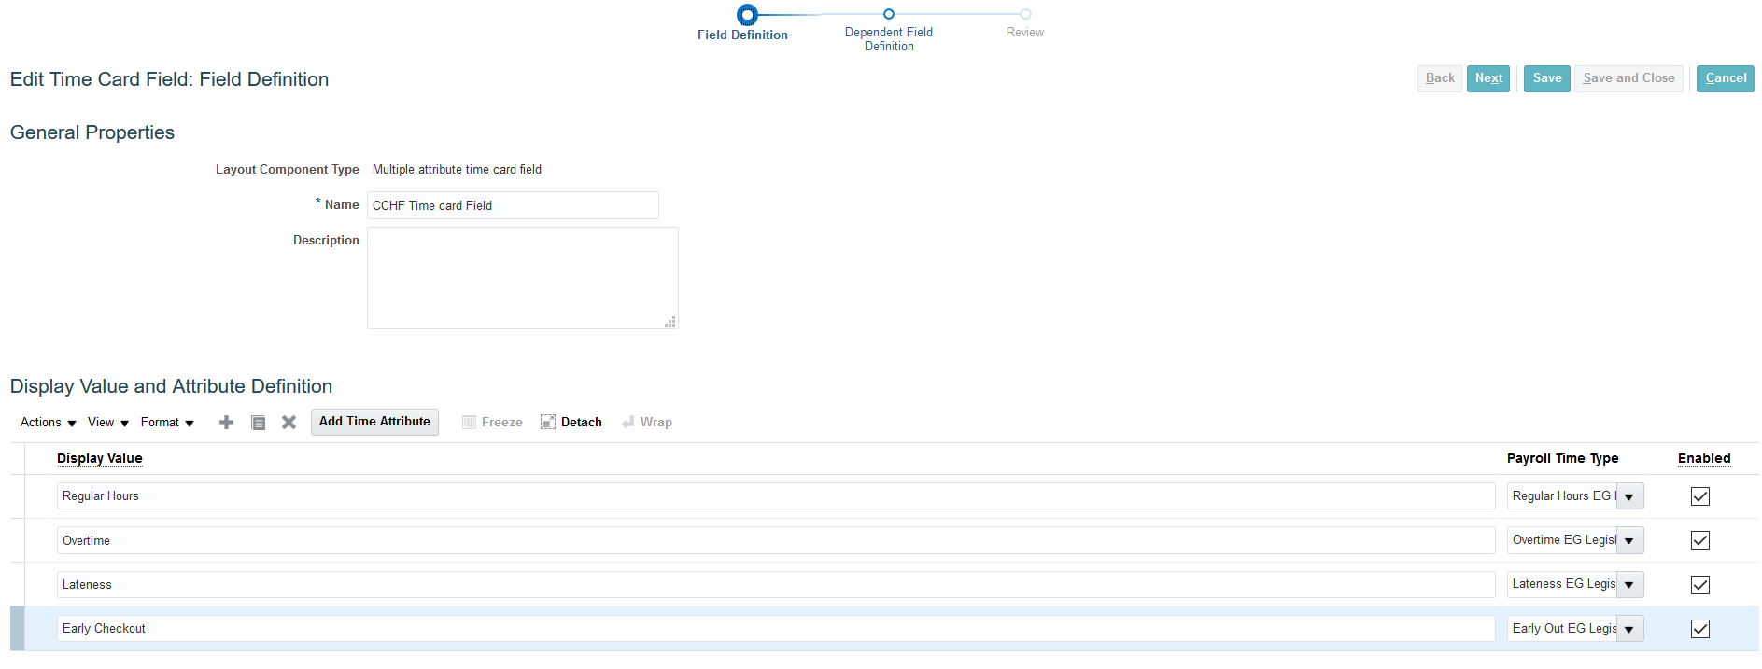

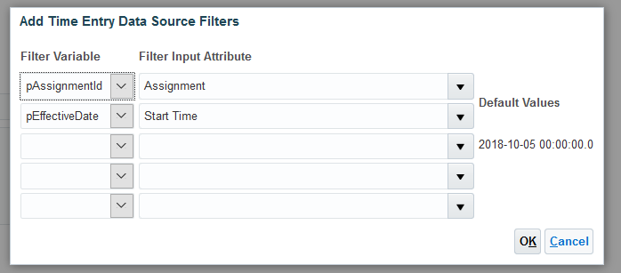

Manage time layout sets
Navigation: - Navigator -> Setup and Maintenance -> Click on Action List -> Search for Manage Time Layout Sets.
Please Follow the Screenshot below for further configuration

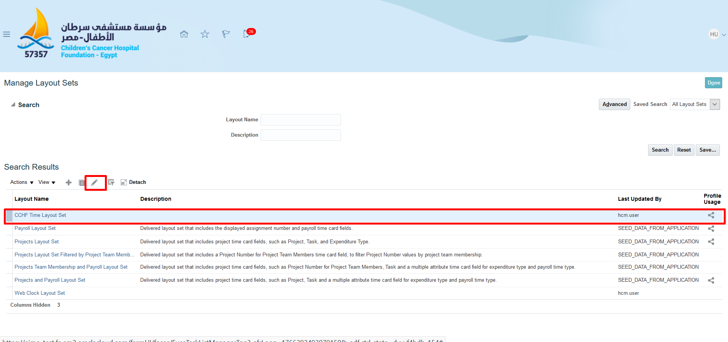

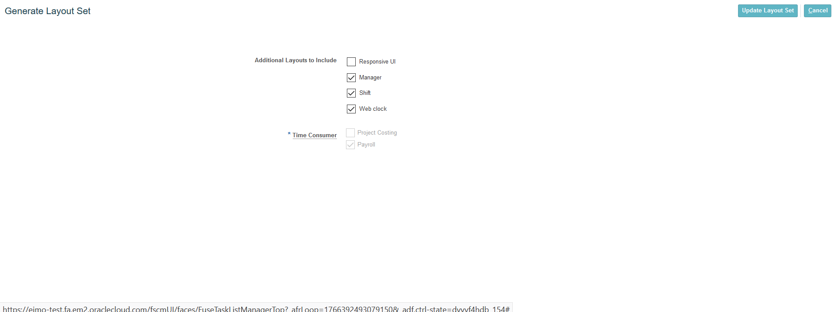

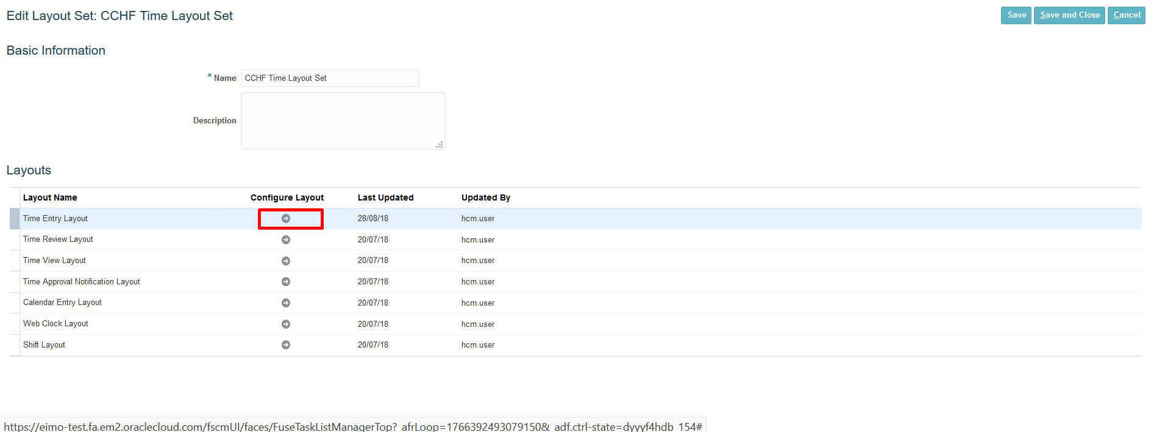

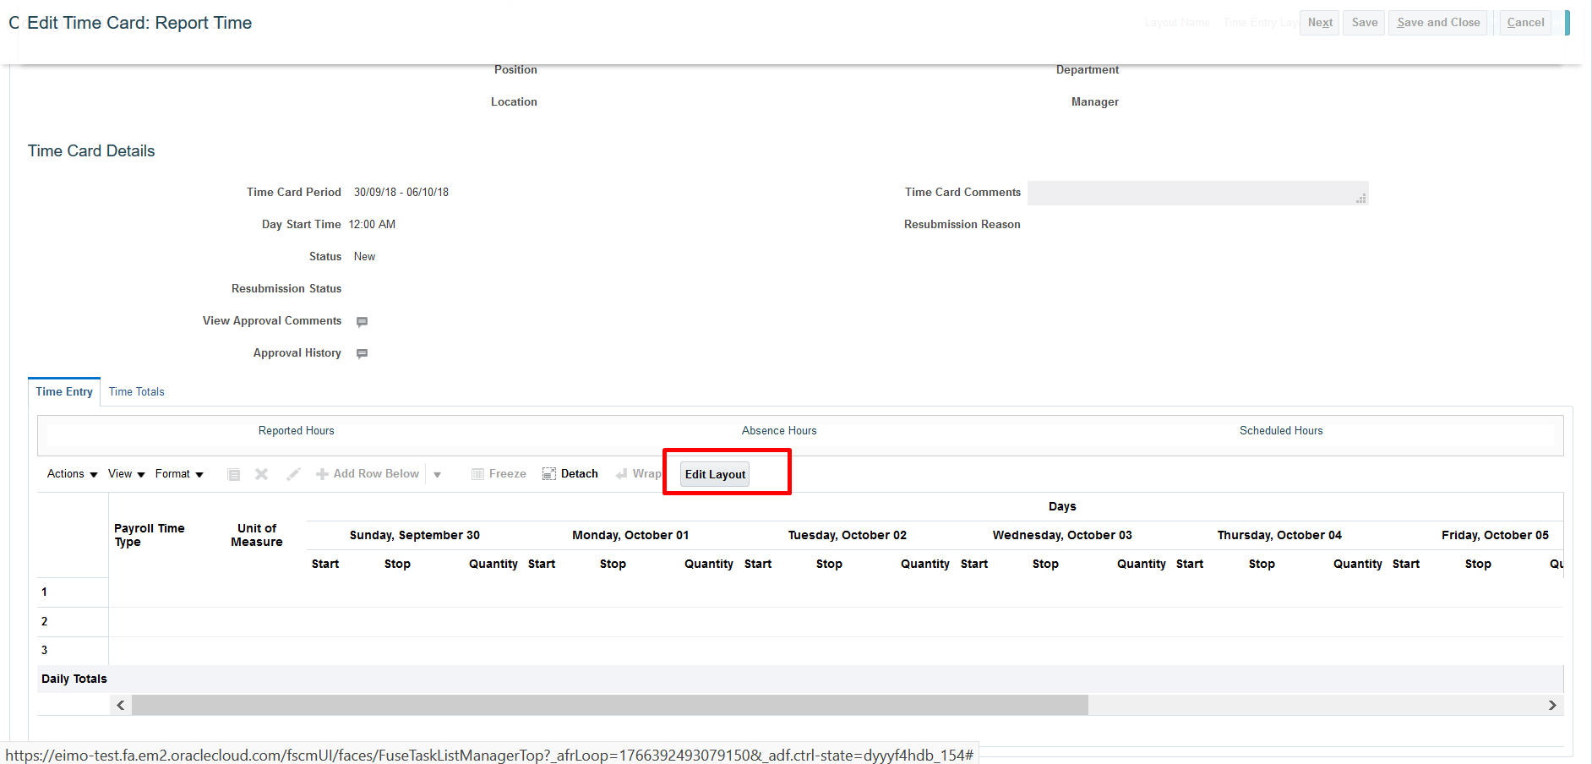

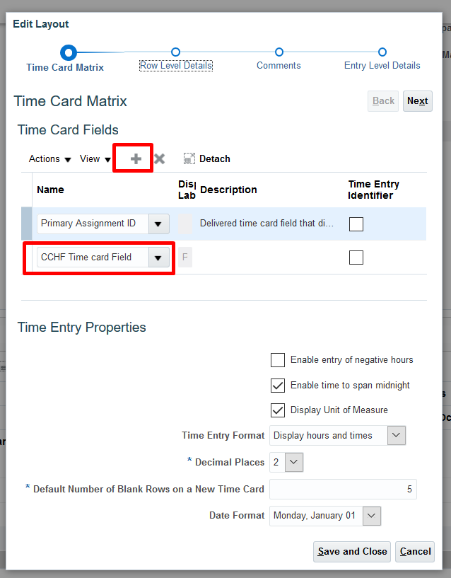

Manage Time Categories

Navigation: - Navigator -> Setup and Maintenance -> Click on Action List -> Search for Manage Time Categories.
Please Follow the Screenshot below for further configuration
Create 4 categories: -

Manage Time Category Set
Navigation: - Navigator -> Setup and Maintenance -> Click on Action List -> Search for Manage Time Category Set
Please Follow the Screenshot below for further configuration

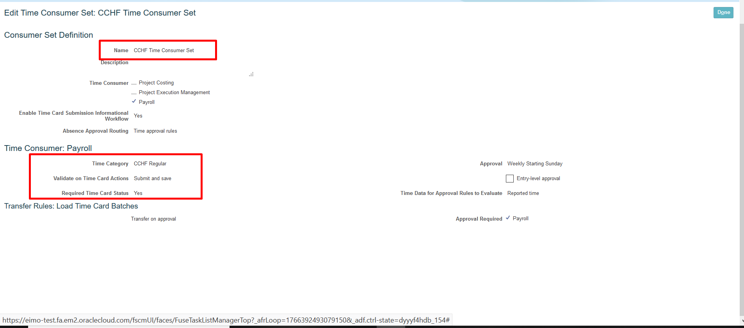

Manage HCM Groups
Navigation: - Navigator -> Setup and Maintenance -> Click on Action List -> Search for Manage HCM Group
Please Follow the Screenshot below for further configuration

